A LESSON IN TALLY SHEETS
Example of a System w/CRT ($7) | Example of a System w/LCD ($5)
 | 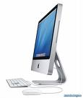
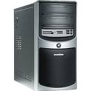
Please mark computer systems (towers) and their monitors separately on the tally sheets!
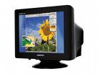


1 system ($5) + 1 monitor ($7) = yay

