Finding the hard Drive:
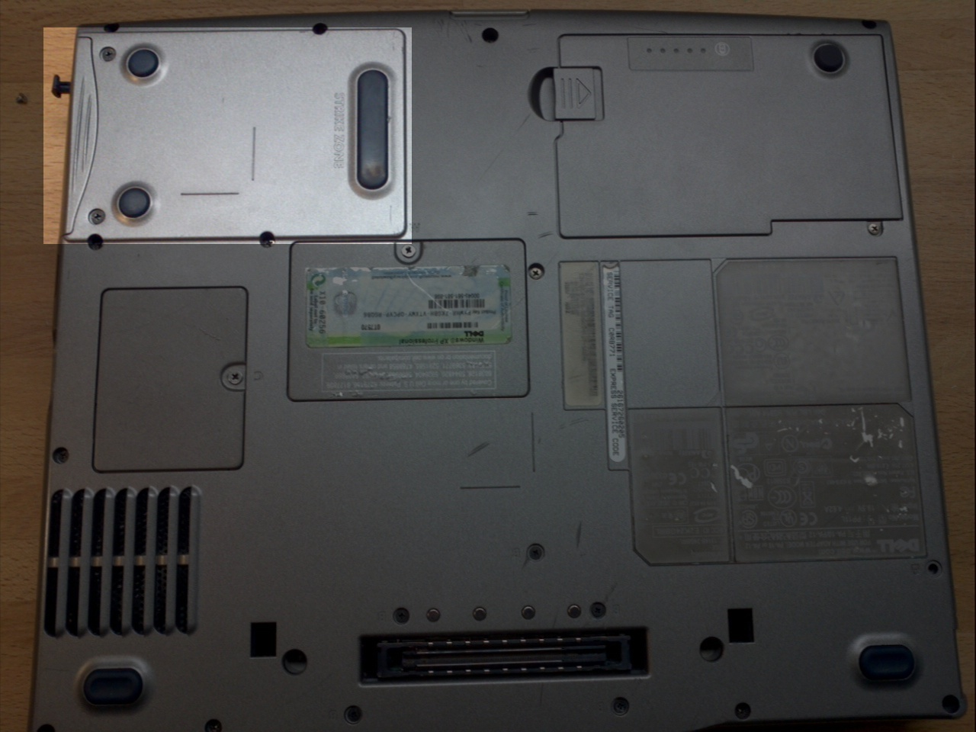
- It could be on the side/bottom

- Remove screws as needed
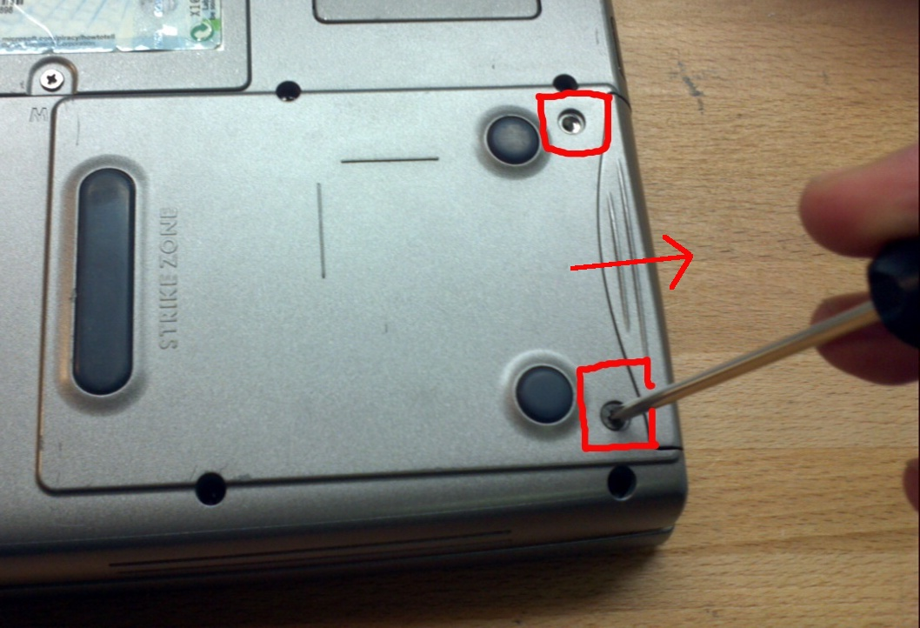
  - be careful to keep track
of said screws
- Remove panels or covers as needed

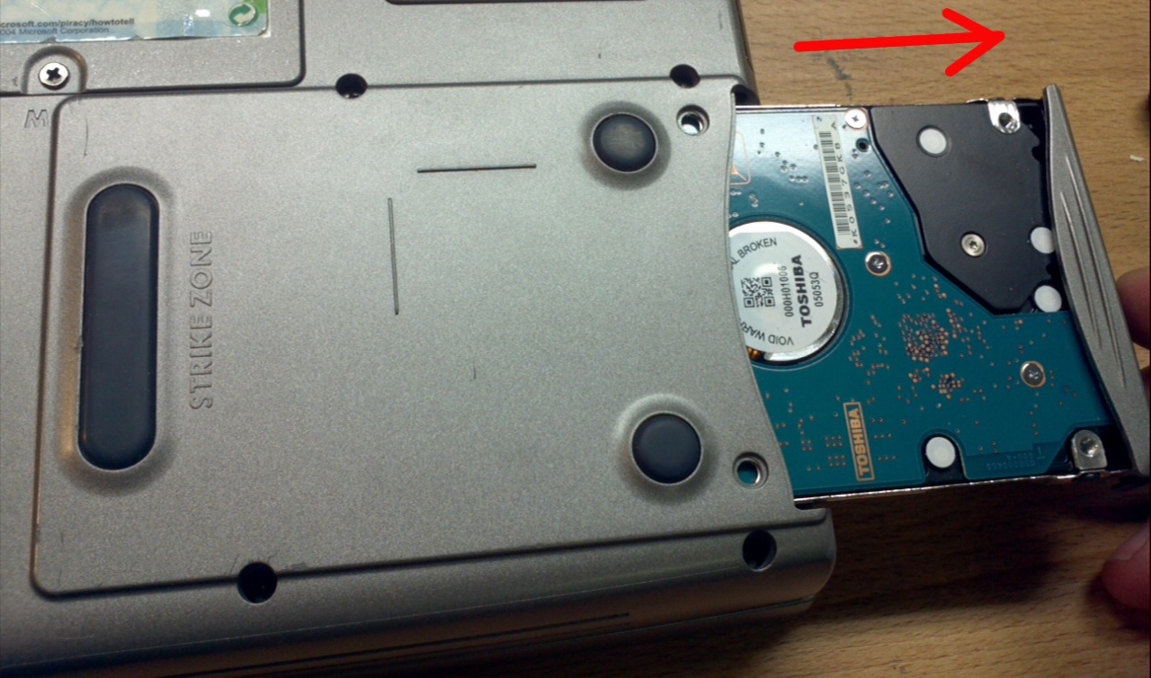
- Slide the hard drive out

- Unscrew & remove the hard drive from its caddy
  - Try and keep the original screws with the caddy. You can use masking tape to wrap up screws, and stick them inside the caddy.
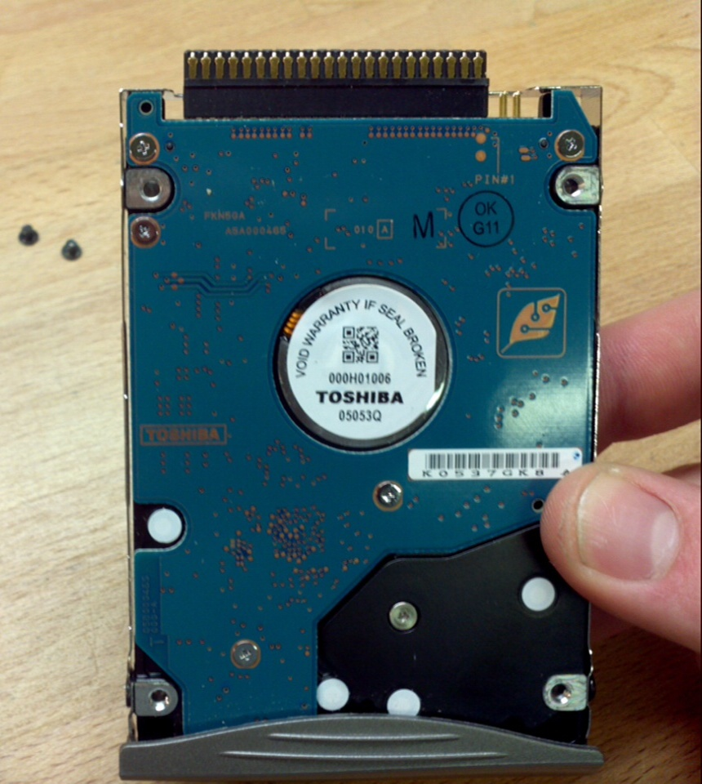
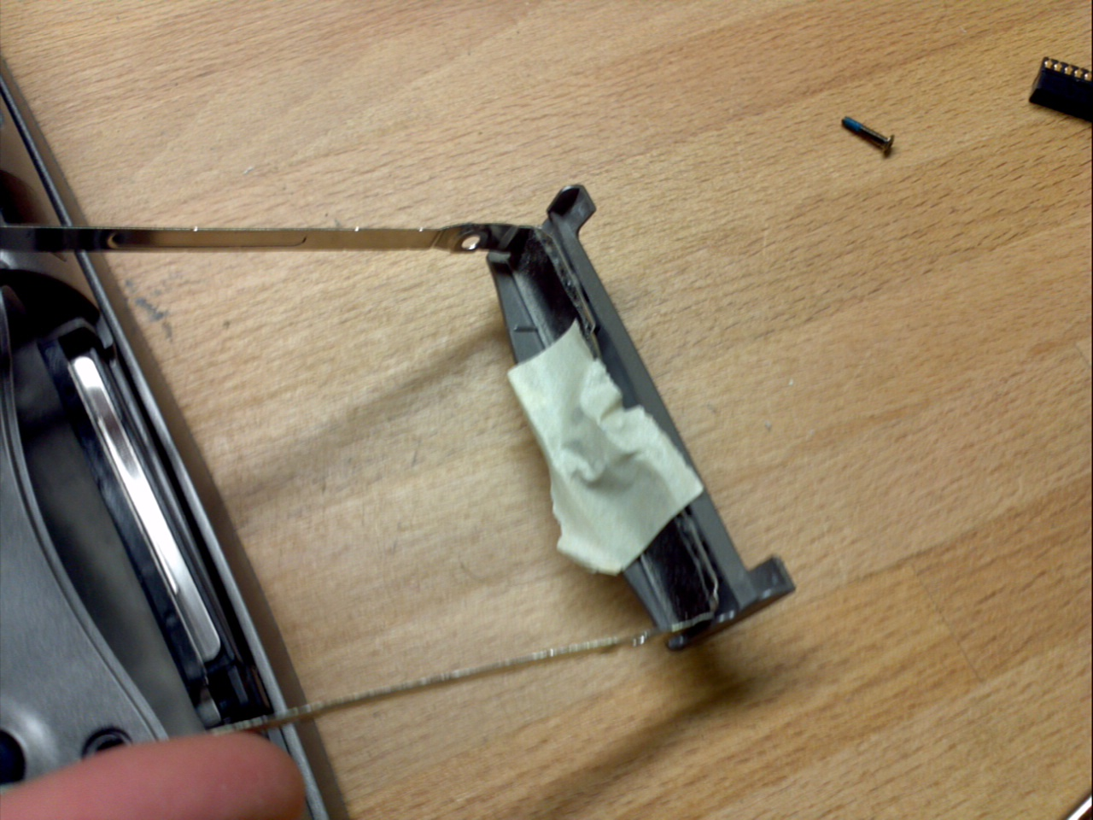

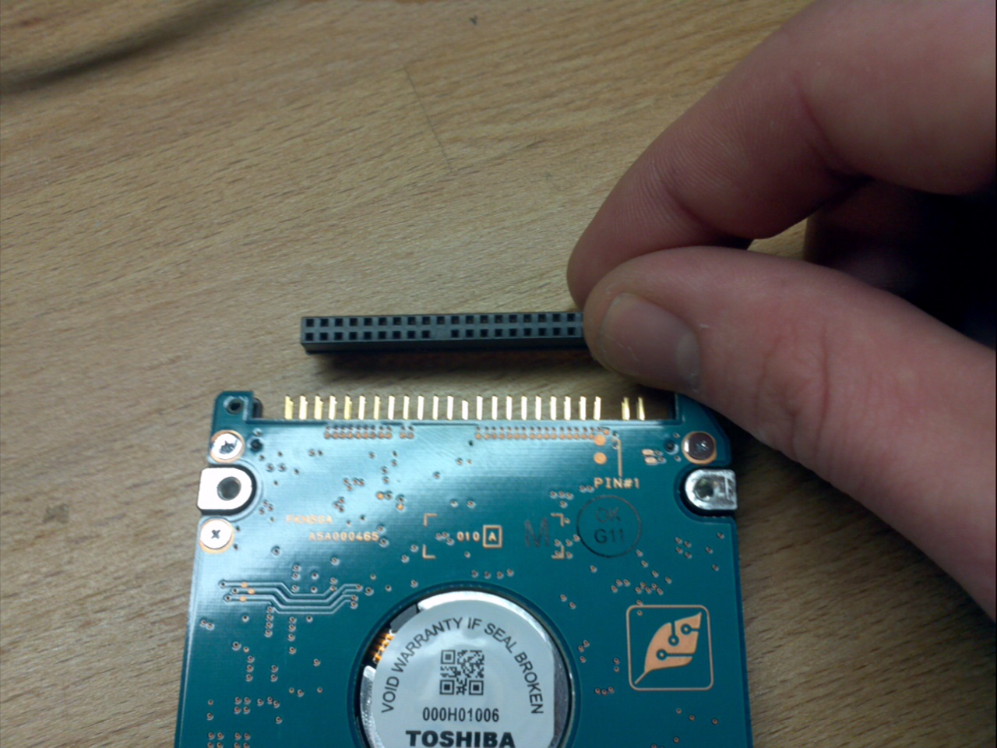
- Remove and adapters that may be present,
they go in the hard drive adapters bin.
  - Be careful not to bend any of the pins (it's fixable if you do, but can be annoying)

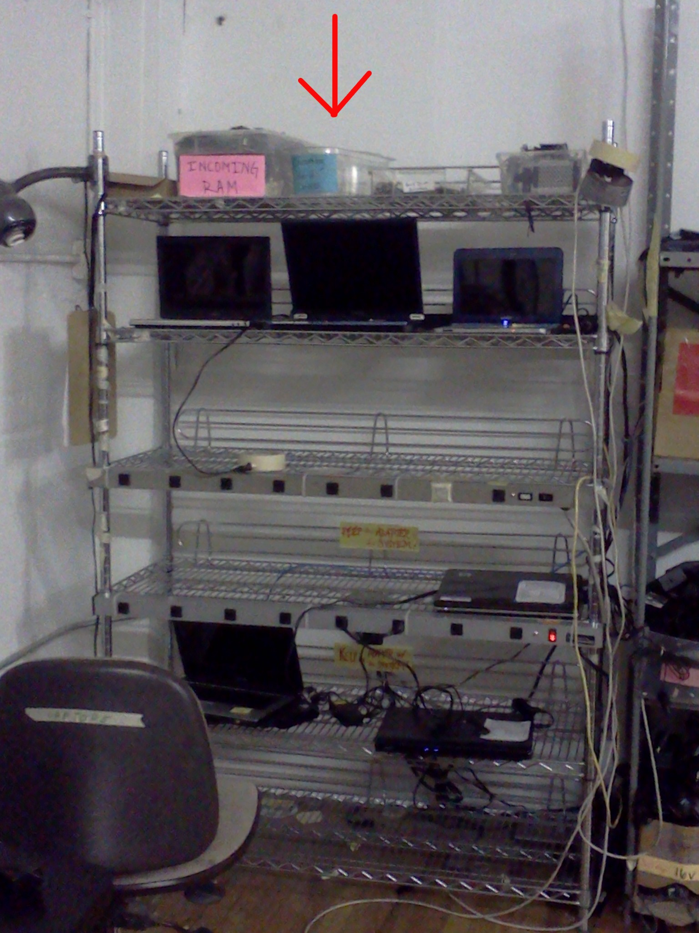

- The removed hard drive can now be placed in the Incoming Hard Drive bin

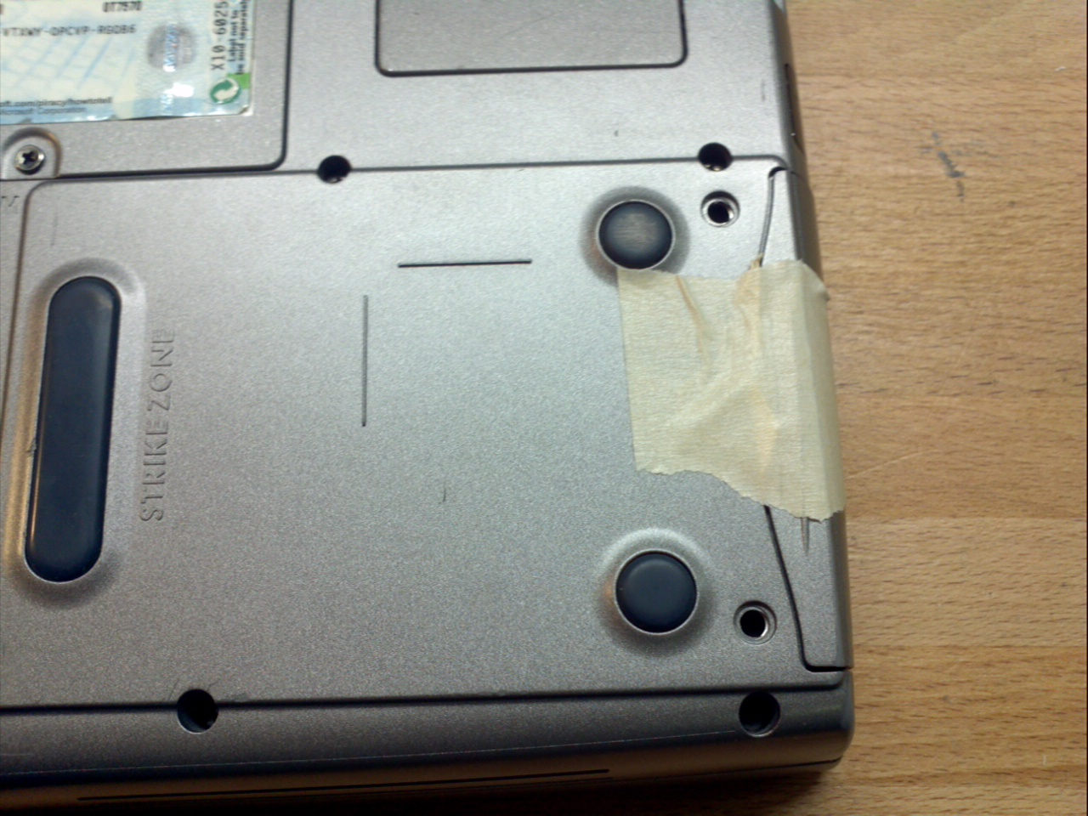
- Slide the hard drive caddy back into
place. If needed, use masking tape
to keep it in place.

