
DON'T give A/V:
Plain RCA cables or TV cables  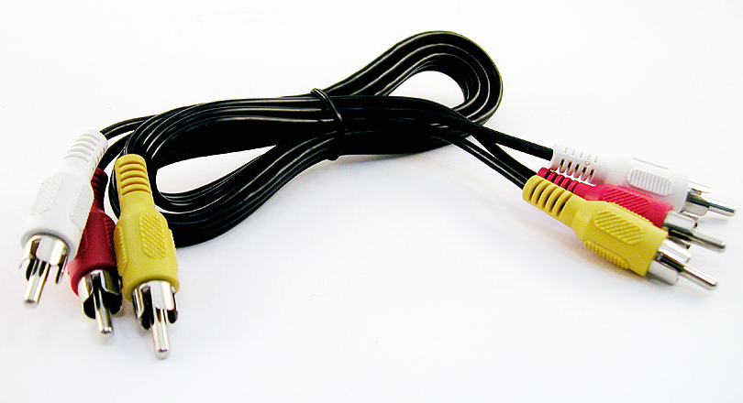 | VCRs that are broken, without remotes, or without red/white/yellow video inputs  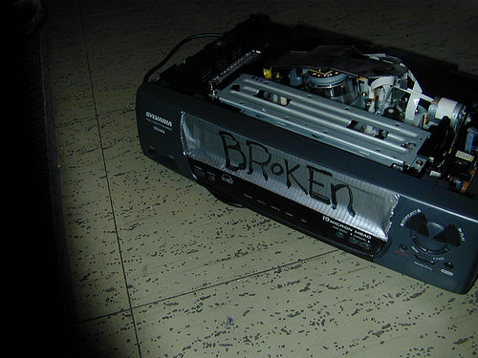  (go to CBM after you cut the cord) | TiVos/DVRs  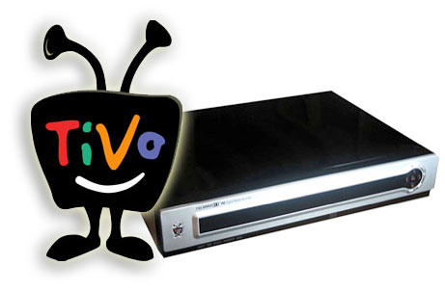  (go to System Eval because they have hard drives)
Satellite receivers or cable TV boxes  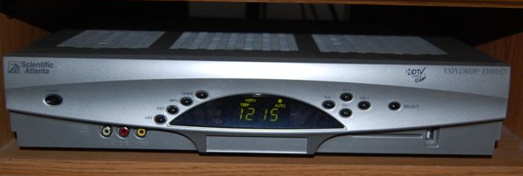  (go to CBM after you cut the cord) | RF Modulators or digital converter boxes  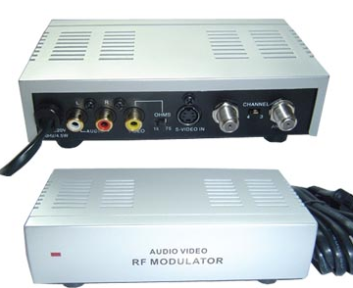  (go to store) | Computer speakers  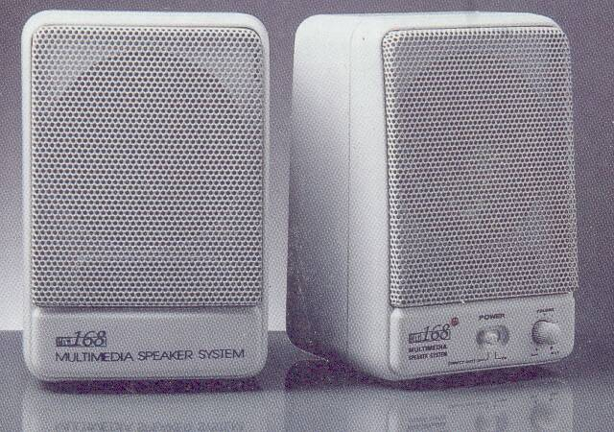
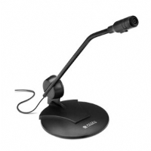  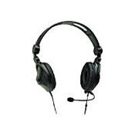  Computer Headphones | Computer microphones | Point & Shoot film picture cameras  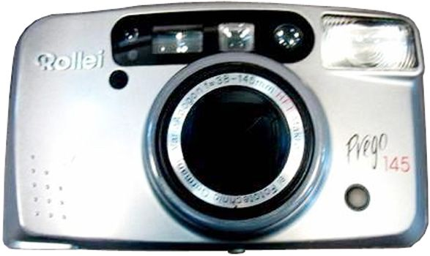  (go to store or recycle)
Digital video cameras  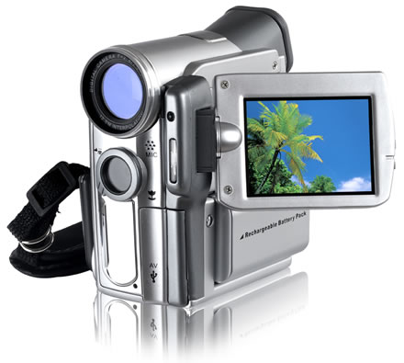  (go to lockbox) | Old antennas without coaxial inputs  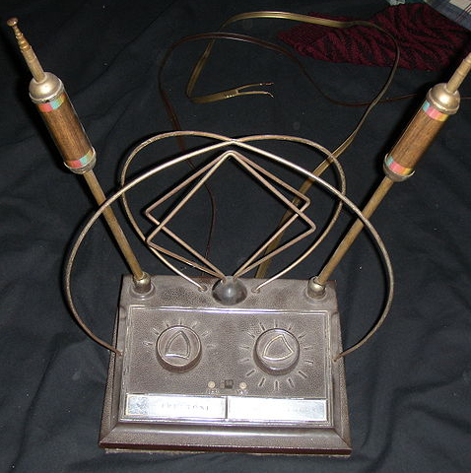 | - Don't give them very broken or very dirty things  - Don't give them tangled messes of cords  Don't stack so tall on the cart that it can come crashing down

