Bulk Sales
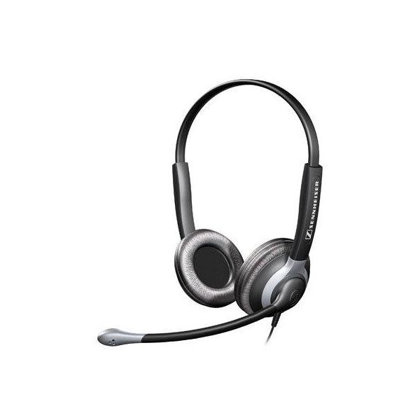  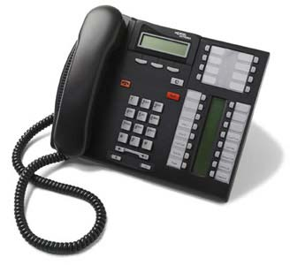  Multi-line phone  systems | Phone headsets  & accessories
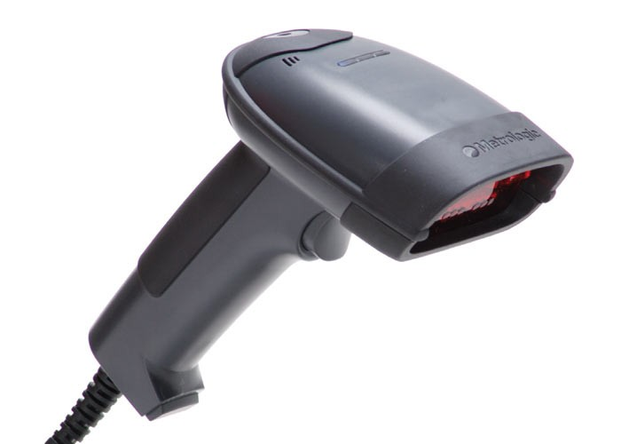  Barcode Scanners | 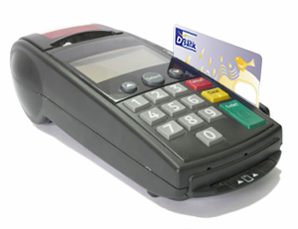  Point of Sales devices  (nothing with a hard drive!)
Anything that says “Plantronics”

