HOW-TO: INSTALL DRIVERS FOR YOUR NEW HARDWARE
From the desk of FreeGeek
(NOTE: This how-to is provided free of charge, as-is, with no implied obligation on the part of FreeGeek or its employees. That means that we will not provide any assistance on this problem beyond providing the steps outlined in this paper. So don't bother calling if something goes wrong or if this does not solve your problem. In addition, FreeGeek, its employees and its volunteers hold no responsibility if any damages occur to your property or person as a direct or indirect result of any instructions in this how-to.)

- First, power down your computer and physically install the hardware. This may range from something as easy as plugging in a cord to something as complicated as taking apart your entire computer. For tips on installing optical drives, hard drives and some other components, see our other how-to guides.

- Once the device is successfully installed, power your computer up and log in. Give the computer time to start completely, usually until you are presented with a fresh desktop and any activity lights on the front of the computer have stopped blinking.
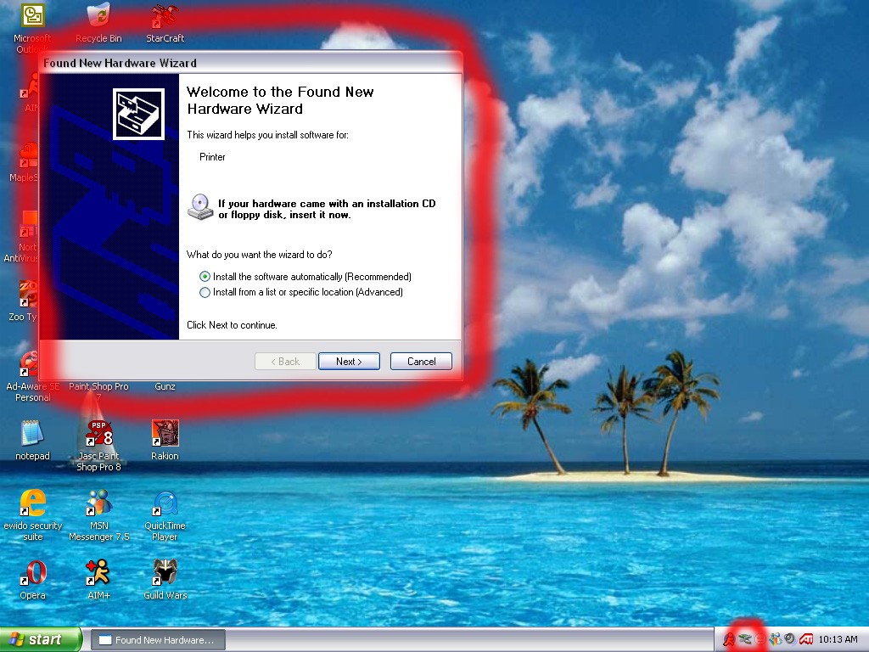Figure 1.

- Windows should recognize that a new hardware device has been added to your computer, indicated by a “Found New Hardware” bubble on the bottom right hand of your screen. Shortly after, the “Found New Hardware Wizard” window will display. Your screen should look something like Figure 1. If this does not happen, continue to the section “Windows Does Not Automatically Recognize My New Hardware” below.
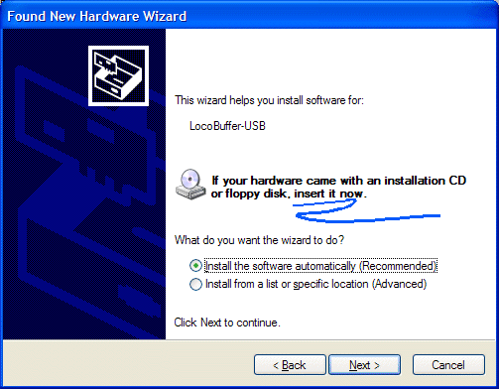Figure 2.

- First, you will let Windows try to find the driver for you. Click the circle next to “Yes, this time only.” This lets Windows connect to the Internet to search for the appropriate driver. If you are not given this option, select the circle next to “Install the software automatically” (Figure 2.) Now click the “Next” button.

NOTE: If your hardware came with a CD-ROM, you should insert it into your CD-ROM drive before clicking next.

- Next, you may be shown a pop-up alert saying that the driver Windows has found for your device “has not passed Windows Logo testing.” If you do see this warning, click “Continue Anyway.”

- If all goes well, the driver will install successfully and your new hardware will be ready to use. You may need to restart your computer before continuing with use of your new device.

- If something goes wrong, and Windows does not find a driver for your device, you will need to find one yourself. If this is the case, see the section below on “Finding and installing drivers for my hardware.”

Windows Does Not Automatically Recognize My New Hardware
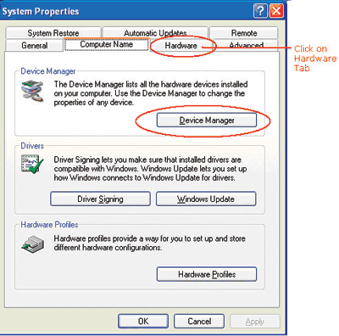Figure 3.

- If after physically installing your device and starting up Windows you do not receive a pop-up notification that Windows has found new hardware on your computer, you will need to manually search for the hardware.

- Go to your desktop, and right-click on the icon labeled “My Computer.” In the menu that pops up, click “Manage.”

- A window will pop up with several tabs along the top. Click the tab that says “Hardware,” and under this screen click “Device Manager” (Figure 3). You will be presented with a list of devices installed on your computer.

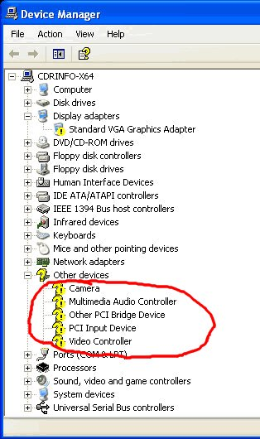Figure 4.
- Try to find the piece of hardware that you've just installed. It may show up under the category it belongs, such as “Network Adapters,” but it may also show up under the category “Other devices.” It may be displayed as “Unknown device,” or “Generic device,” or it may have a more descriptive name. It will, however, have a small Icon to the left of its name featuring a yellow question mark.

- After you've found the new device, right-click it and select “Properties” from the menu that appears. You will be shown another window with tabs along the top, and you should go to the “Driver” tab. Under the “Driver” screen, click “Update Driver.”

- Now you should be able to continue from Step 3 above.

Finding and Installing Drivers for my Hardware
NOTE: You will need an Internet connection to complete these steps.

- First, you will need the brand and model number for your device. There are several ways of finding this, but most likely you will need to look at the hardware itself. If it is an optical or hard drive, the brand and model number will be somewhere on the casing of the drive. If it is a card, you may need to look at the small print on the actual card itself, or for stickers attached to the back of the card. Most external devices will have the brand and model displayed prominently on the outside.

- Next, go to the manufacturer's website. Usually the website is just the manufacturer's name plus a ".com" For example, if you had a Netgear WG511T Wireless card, you would go to netgear.com, and if you had an MSI ATI 1300 video card, you would go to the MSI website. If the manufacturer's website plus ".com" doesn't work, go to a search website such as google.com, and type in the manufacturer's name. Usually the first result is the website you want.

- Once you find the manufacturer's website, you will need to find the support section, where most manufacturers keep information on their drivers. The support section is typically found through a button near the top of the screen. Click that button. When you've reached the support section, look for a search box. In the search box, type the device's model number. With the example of the Netgear card mentioned in step 2, you would type “WG511T” into the search box. After you enter in your model number, click “Search,” and you should be taken to your device's home page. There, look for a button or link that says “Drivers.”

NOTE: Different manufacturer's websites vary greatly, and may not be constructed the same way that is outlined in this step. Don't assume that just because there is not a link to a support section that drivers are therefore not available.

- Once you have found the list of drivers for your device, choose which driver is best for your computer. There will likely be many different types of drivers available. Since this how-to is directed at Windows XP users, you should choose a driver that is built for Windows XP. You may also need to choose between 32-bit and 64-bit drivers. Determine if your computer is 32- or 64-bit, and choose the correct one.

NOTE: If you are unsure whether your computer is 32- or 64-bit, you can likely assume it is 32-bit. Most standard desktop and laptop computers are 32-bit.

- Now you will need to download the drivers. Once you have found the correct driver for your system, click on the download link. Sometimes you will have to go through a series of download links to download it. If you click a link to download, and your website browser shows the website is trying to download the file, have the browser accept it. In a few seconds, depending on your computer, a box will show up asking if you want to run the file directly, or save it to your computer. Choose to save it, and save to a location you can easily remember, such as your desktop.

- After the download is complete, find where you have saved the driver. If the file you downloaded ends with “.exe” or does not have an ending, double-click the file and follow the ensuing instructions. This should successfully install the drivers for your device.

