Store

- Many items that are new in the bag or box and unopened – ASK FIRST

- Cables and Adapters that are on the “Special Requests” Board

- Surge Protectors and Extension Cords

- Empty Laptop Bags

Holding Tank
(laptop accessories)

- Laptop Drives
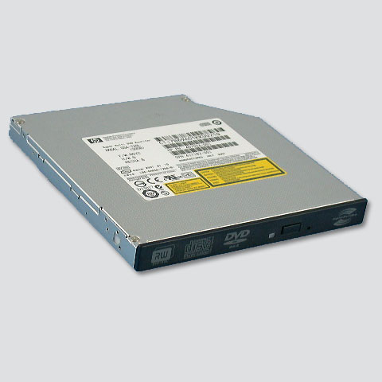
(thinner than regular drives)

- Laptop Power Adapters

- PCMCIA or PC Cards

Printer Ink & Toner

- Used and New Ink Cartridges
- Used and New Toner Cartridges
- Ink Refilling Kits

New Ink and Toner should be left in the original packaging
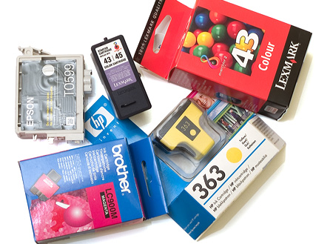
PDA / Digital Camera Accessories

- PDA Accessories

- Digital Camera Accessories

- Web Cams

PDAs & Digital Cameras GO IN THE LOCK BOX!

Audio/Visual Stuff

Cell Phone Accessories

- Cell Phone Batteries

- Cell Phone wall chargers (the ones that plug into a wall outlet)

- Cell Phone Car Chargers

CELL PHONES GO IN THE LOCK BOX

Games

- Joy Sticks

- Controllers

- Computer Games (CDs and Cartridges)

- Anything related to computer or personal gaming systems

Online Sales

- Multi Line Phones

- Cisco Systems

- Antique Electronics

Wireless Mice
and Keyboards

- REMEMBER to include the wireless receiver!

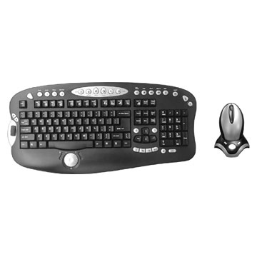
Mouse Pads

- Mouse Pads!!

Only Mouse Pads that are CLEAN
(ones that you wouldn't mind using yourself)

Dirty Mouse Pads generally get put on the free table or in the garbage

