Wall Warts Wall wart is a slang term for certain types of power supply - typically those that are embedded in an over-sized AC plug and typically packaged with electrical devices that do not contain their own power supply.

- All Wall Warts Go Here

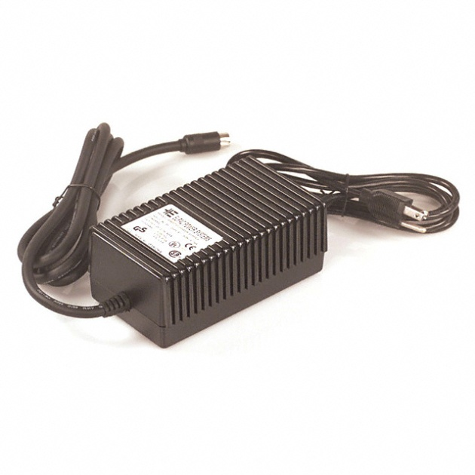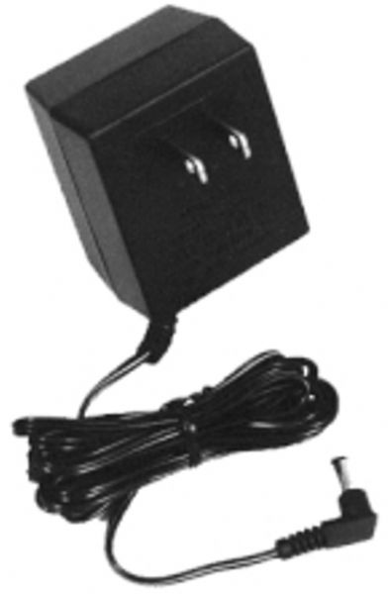 EXCEPT:
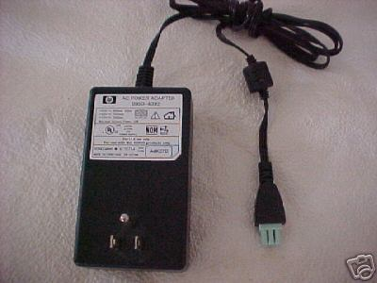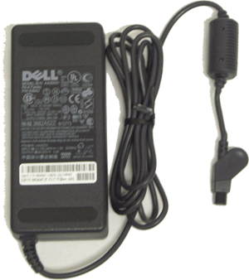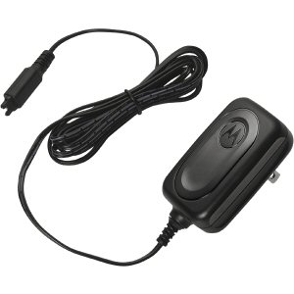
Printer Power Supplies Laptop Power Supplies Cell Phone Power Supplies
(Go into Printer Accessories) (Go into Laptop Accessories) (Go into Cell Phone Accessories)

