
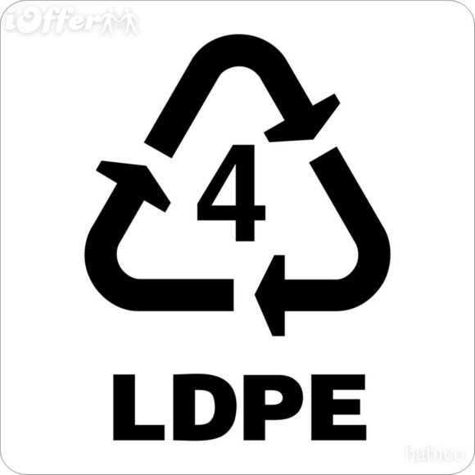
Filmy Plastic
CLEAR PLASTIC!!
#2 Plastic, #4 Plastic, Stretches around your thumb, Zip Lock Bags

DOES NOT GO IN:
Colored Plastic
Bubble Wrap
Crinkly Plastic
Easily Ripped Plastic

