Thin Colored Wire

Thin Colored Wire is wire that is not heavily insulated
(the rubber coating is not as thick as standard cords and cables)

It's fine if small L.E.D. lights and small connectors to remain attached

Ribbon Cables

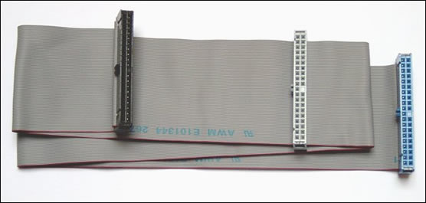
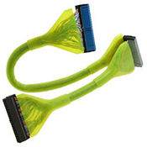

Ethernet Cables

- All Ethernet Cables

NO Phone Cables (see image) – recycle them

USB Cables
(Universal Serial Bus)

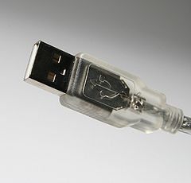
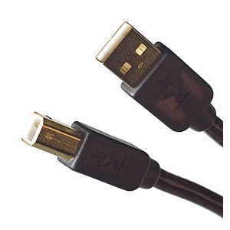
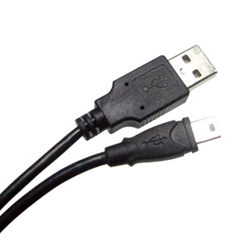

Wall Warts
Wall wart is a slang term for certain types of power supply - typically those that are embedded in an over-sized AC plug and typically packaged with electrical devices that do not contain their own power supply.

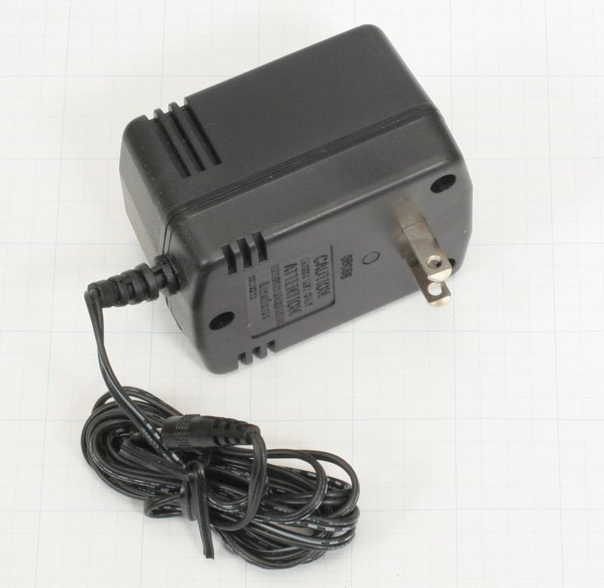

DVI Cables
(Digital Visual Interface)
usually WHITE
two squares
19 pin
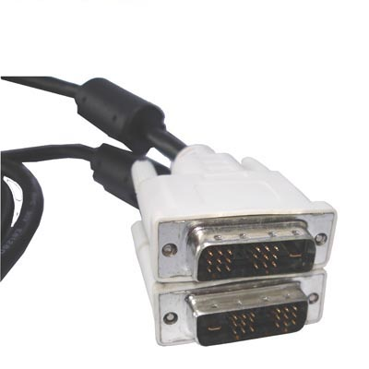

VGA Cables
(Video Graphics Array)
usually BLUE
three-row
15 pin



