Games
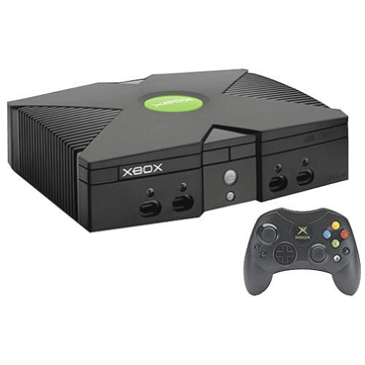    All game systems:  X-Boxes,  Play Stations, etc. | 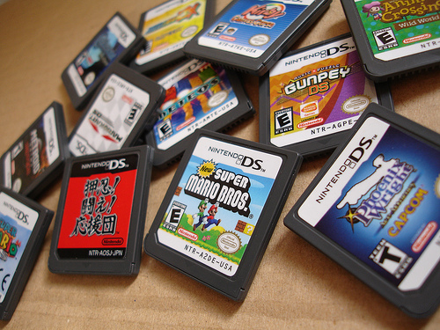  Computer Games (CDs and Cartridges)
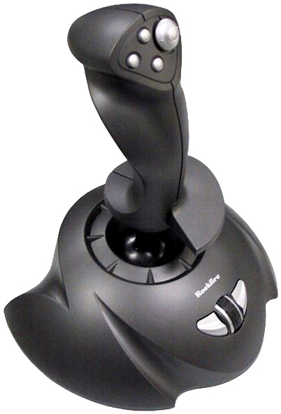  Joy Sticks | Anything related to computer or personal gaming systems
Controllers


