PRINTERLAND
- Questions? Ask: Jake
- DO give them:
Printers | Multi-function Printers  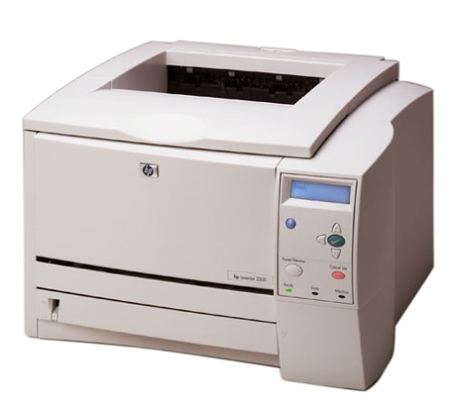  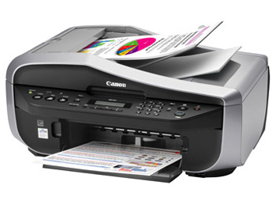  (Print/Scan/Fax) | Fax Machines  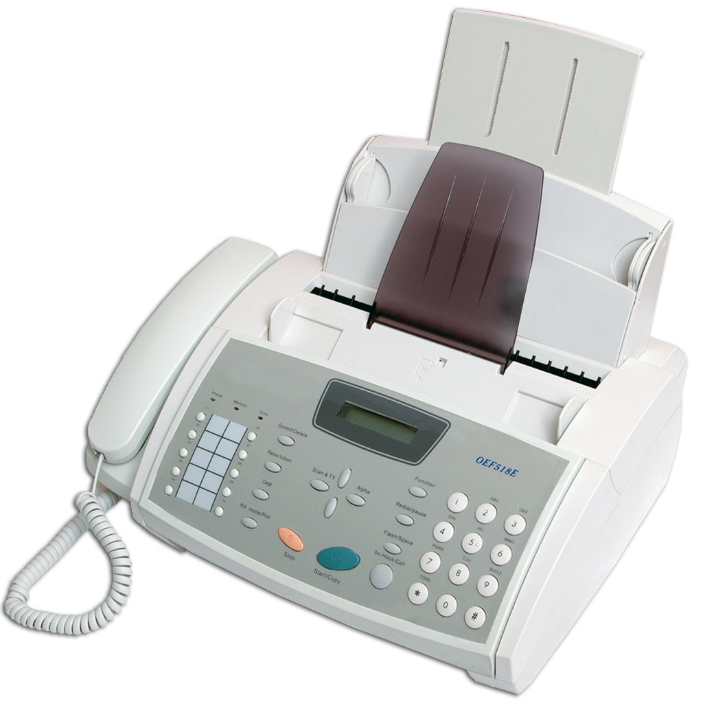
Scanners  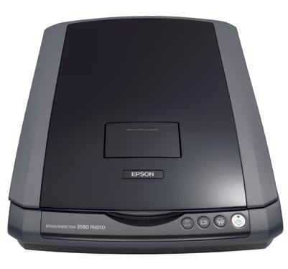 | Typewriters  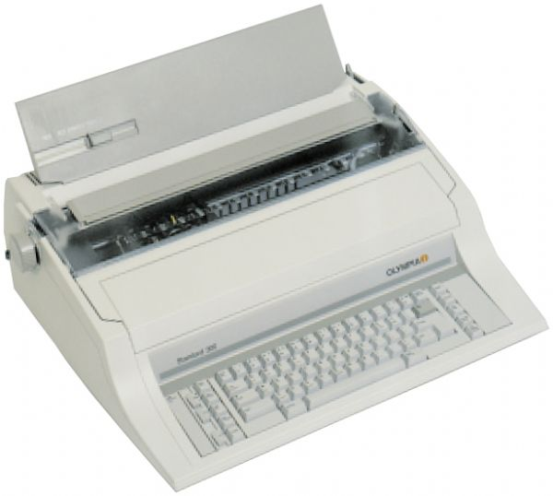 | Label-makers  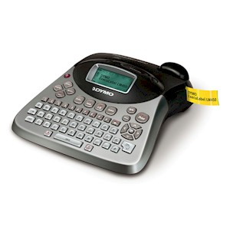
Point of Sale Machines  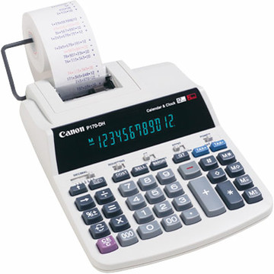  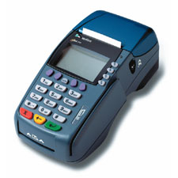  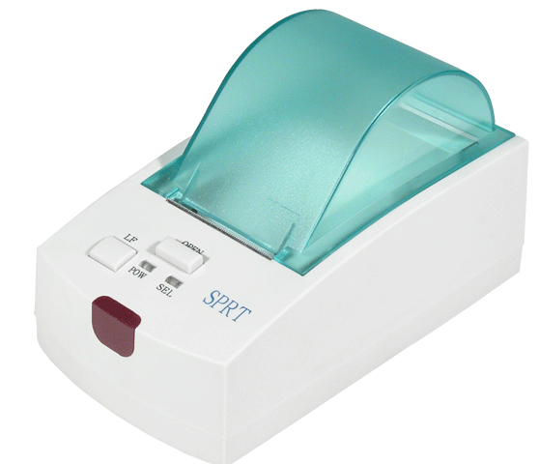  Receipt Printers | Adding Machines | Hand-held & Slide Scanners  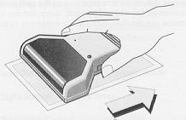
New/Used Ink Cartridges  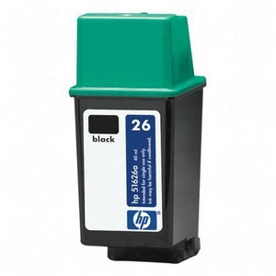 | New/Used Toner  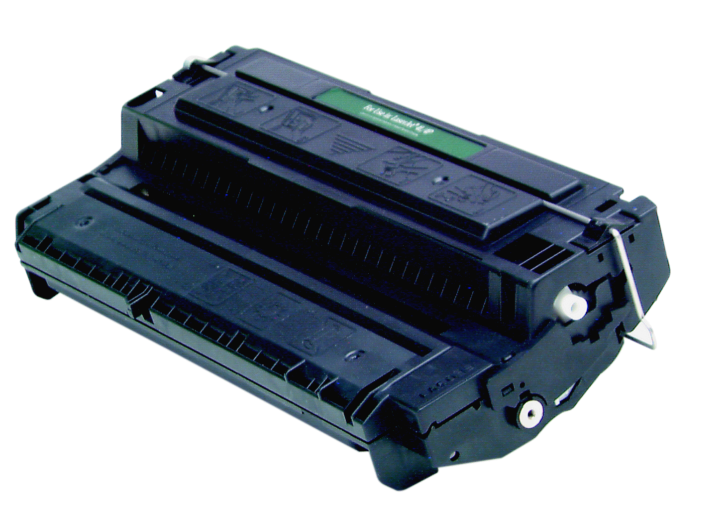  Keep toner in package, no matter what!
  - DO keep the wall warts/transformers with the printers
  - DO keep plastic trays and accessories with the printers
  - DO keep printer ink/toner in the packaging

- DON'T give them:
Photocopiers  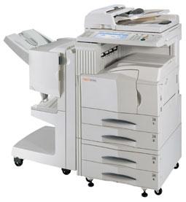  If they can't connect to a computer, we have to send them to Far West Fibers | Print Servers  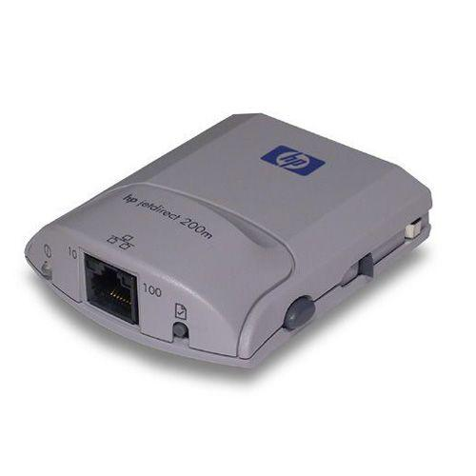  A print server is a device that allows computer workstations to interface with one or more printers that are shared on a network. These go to Network Devices/Advanced Testing | Shredders  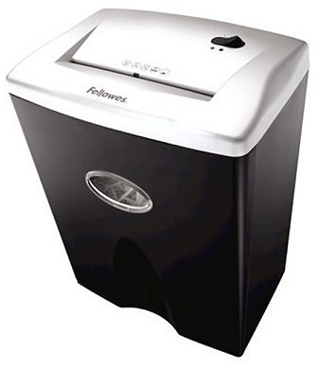  Test shredders in Receiving. If they work, send them to the Store. If they don't work, the cord should be clipped and recycled, the shredder will become CBM, and the bin will become dirty plastic.
- DON'T put printers on their sides on the shelves or on the carts (toner may leak)
- DON'T keep manuals/CDs/packaging with printers (it's available online)

