Online Sales
“Clicky” Keyboards  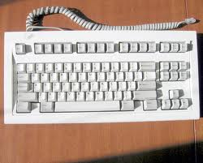 | Multi Line Phone Systems  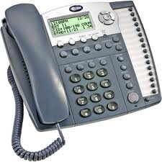  *Full sets only*
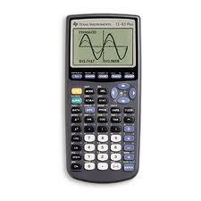  Graphing Caluclators | 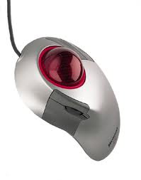  Trackball Mice  (Microsoft only)
Tools and accessories for tool | Antique electronics

