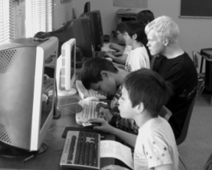
mission
FREE GEEK is a nonprofit community organization that reuses and recycles technology to provide computers, education and job-skills training in exchange for community service.
Reuse Before Recycling
Free Geek firmly believes that reuse is the highest form of recycling, so we strive to get technology back into use in the community. We have donated over 10,000 refurbished computer systems to volunteers, local schools, and nonprofits.

Responsible Recycling
What cannot be reused is recycled responsibly. Free Geek has diverted over 3,500 tons of electronic waste from our landfills, preventing toxins from leaching into our soil and water.
Donated computers at St. Maries Christian School
programs
Volunteer Programs
By volunteering your time and skills at Free Geek, you can earn a free refurbished desktop computer. Over 18,000 individuals have volunteered in Free Geek programs. They have accumulated over 550,000 hours of volunteer service helping Free Geek fulfill our mission since 2000.

Classes
Beyond the education provided by our volunteer programs, Free Geek also offers a variety of computer classes that are free and open to the community. All classes focus on free and open source technologies including Ubuntu Linux. Stop by or visit our website to learn more: www.freegeek.org/classes

Hardware Grants
The Hardware Grants Program offers qualifying non-profits needed and available refurbished computer equipment for free. Visit our website to learn more and fill out an application
www.freegeek.org/grants

Thrift Store
Our Thrift Store caters to novices and hard-core tinkerers, alike. We sell everything from cables to computer systems, all at inconceivably low prices. Every purchase directly supports Free Geek's Community Technology Center! Drop by. We'll hook you up.

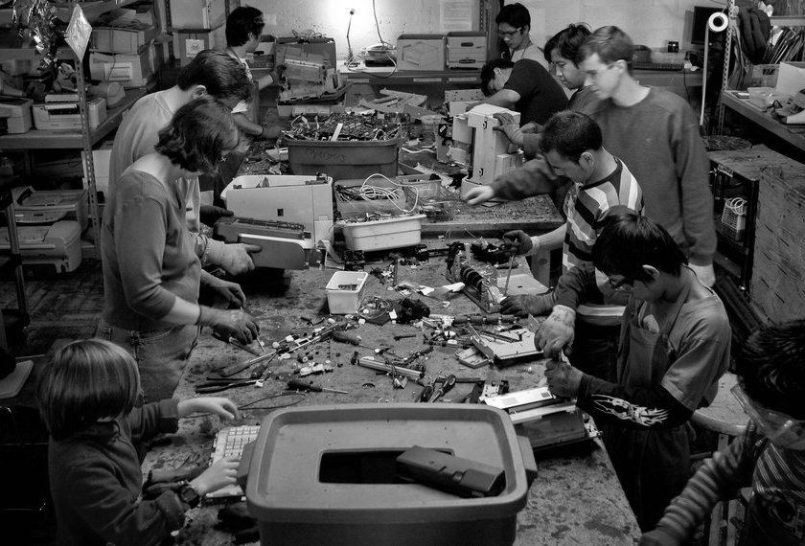
volunteer
Getting Started
The first step to getting plugged in at Free Geek is to take a tour. Tours are available 11 AM and 4 PM, Tuesday through Saturday.

Adoption Volunteers deconstruct printers to recycle
Adoption Program
You are eligible to earn a free computer after 24 hours of volunteering in our recycling and receiving areas. We then provide a class to help you use your new computer and a year of free tech support.

Build Program
You can learn how to build computers without any prior experience through this self-paced, step-by-step program. After building five computers, the sixth is yours to take home.

Volunteer Internships
Individuals looking to gain job skills or spiff up a resume can apply online for an internship in various Free Geek areas.
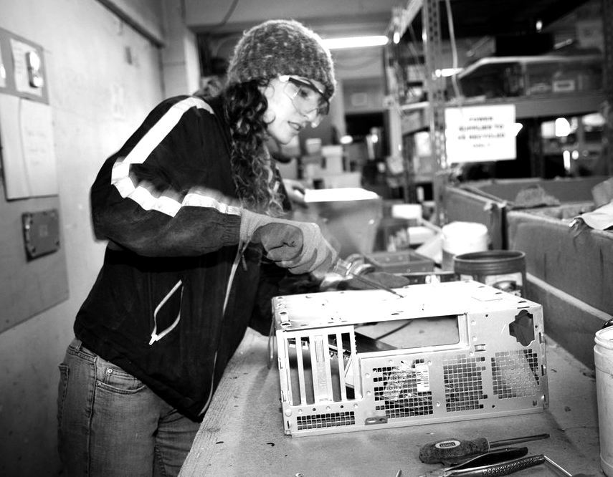
contribute
Donate Your Used Technology
Free Geek is an official Oregon E-Cycles collection site and accepts donations of computer equipment and consumer electronics. There are no fees for individual donors. If you are a business or organization you may call to inquire about fees. Donations are tax deductible and help support our programs.

If you wish to donate large quantities of equipment (more than 15 systems) or to arrange for a pick-up, please call us.

Contribute Money
Monetary donations go a long way in helping Free Geek fulfill its mission of diverting technology away from landfills and into the hands of those who need it. Donate online at www.freegeek.org or stop by our front desk. Contributions are tax deductible and directly support our programs.
connect

Visit our Community
Technology Center

Location
1731 SE 10th Ave.
Portland, OR 97214
(2 blocks South of Hawthorne on SE 10th Ave.)

Hours
Open Tuesday – Saturday
10 AM – 6 PM

Tours
Offered Tuesday – Saturday
11 AM and 4 PM
Visitas guiadas en español a las 10:30 AM los sábados

Visit our Thrift Store
(Same hours and location)

Contact Us
(503) 232-9350
info@freegeek.org

www.freegeek.org

We're social!
www.facebook.com/freegeekmothership
https://twitter.com/FreeGeekPDX

Some photos courtesy Shawn Linehan



Recycling and reusing technology to provide computers, skills and education to our community

www.freegeek.org


