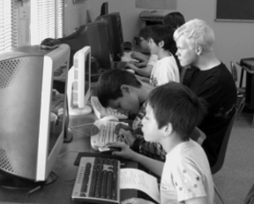
mission
FREE GEEK is a 501(c)3 nonprofit community organization that reuses and ethically recycles technology to provide computers, education and job-skills training in exchange for community service.
Reuse Before Recycling
Free Geek firmly believes that reuse is the highest form of recycling, so we strive to get technology back into use in the community. We have donated over 17,300 refurbished computer systems to volunteers, local schools, and nonprofits.

Responsible Recycling
What cannot be reused is responsibly recycled . We have diverted well over 6,200 tons of electronic waste from our landfills, preventing toxins from leaching into our soil and water. We only work with recyclers who adhere to the highest environmental standards.
Donated computers at St. Maries Christian School
programs
Volunteer Programs
By volunteering your time and skills at Free Geek, you can earn a free refurbished desktop computer. Over 29,000 individuals have volunteered in Free Geek programs. They have accumulated over 745,000 hours of volunteer service helping Free Geek fulfill our mission since 2000.

Classes
Beyond the education provided by our volunteer programs, Free Geek also offers a variety of free computer classes open to anyone in the community. Classes cover a wide range of topics from free and open source technologies to creating an online presence for your business and using technology for a successful job search. Stop by or visit our website to learn more: www.freegeek.org/classes

Hardware Grants
The Hardware Grants Program offers qualifying non-profits, schools, and community change organizations needed refurbished computer equipment for free. Visit our website to learn more and fill out an application: www.freegeek.org/grants

Thrift Store
Our Thrift Store caters to novices and hard-core tinkerers, alike. We sell everything from cables to complete computer systems, all at reasonable prices. And every purchase directly supports Free Geek's mission! We also sell online through eBay and Amazon:
Ebay - http://is.gd/fgebay
Amazon - http://is.gd/fgamazon
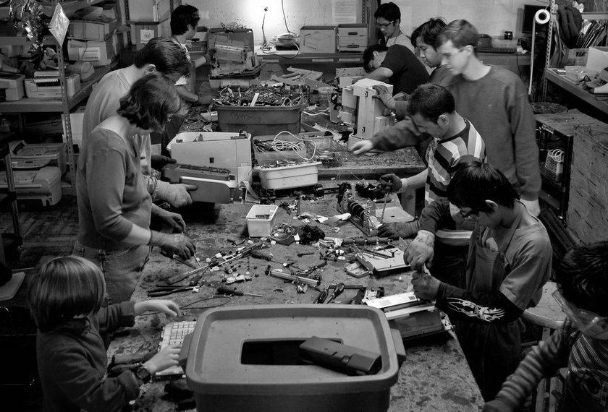
volunteer
Getting Started
The first step to getting plugged in at Free Geek is to take a tour. Approximately 30 minute tours are available 11 AM and
4 PM, Tuesday through Saturday.
Adoption Volunteers deconstruct printers to recycle
Adoption Program
You are eligible to earn a free desktop computer after 24 hours of volunteering in our recycling and receiving areas. You also get a free class to help you use your new computer and a year of free tech support.

Build Program
You can learn how to build computers without any prior experience through this self-paced, step-by-step program. After building five computers, the sixth is yours to take home.

Volunteer Internships
Individuals looking to gain job skills or add to their a resume are encouraged to apply online for an internship in various areas:
www.freegeek.org/internships
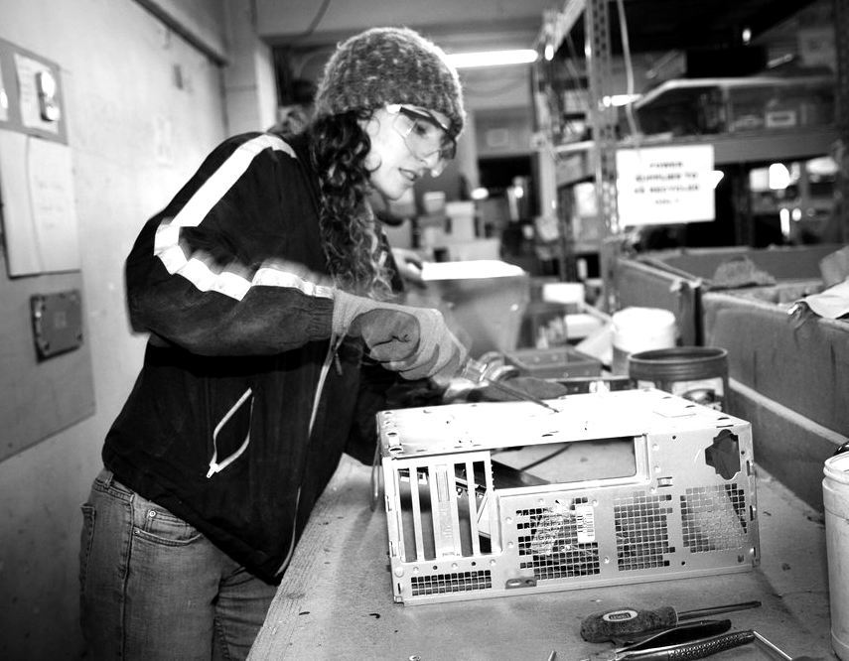
contribute
Donate Your Used Technology
Free Geek is an official Oregon E-Cycles collection site and accepts donations of computer equipment and consumer electronics. There are no fees for individual donors. If you are a business or organization you may call to inquire about fees. Donations are tax deductible and help support our tech education programs.

If you wish to donate large quantities of equipment (more than 15 systems) or to arrange for a pick-up, please call us.

Contribute Money
Your tax-deductible monetary donations are essential to help Free Geek fulfill its mission of diverting technology away from landfills and into the hands of those who need it. Stop by our front desk or donate online: www.freegeek.org/donate. Your contributions directly support our many community programs including our grants program, free classes, internships and job skills training.
connect

1731 SE 10th Ave.
Portland, OR 97214
(2 blocks South of Hawthorne on SE 10th Ave.)

HOURS
We accept hardware & cash donations:
Tuesday – Saturday
10 AM – 6 PM

Shop for reused items in our store:
Monday – Saturday
10 AM – 6 PM

Shop online anytime:
Ebay - http://is.gd/fgebay
Amazon - http://is.gd/fgamazon

Volunteer orientation & tours
Tuesday – Saturday, 11AM & 4PM
(each tour is approximately 30 minutes)
Visitas guiadas en español,
los sábados 10:30 AM

(503) 232-9350

info@freegeek.org

Find us online
www.facebook.com/freegeekmothership
https://twitter.com/FreeGeekPDX
https://twitter.com/FGThriftStore
http://lists.freegeek.org

Some photos courtesy Shawn Linehan


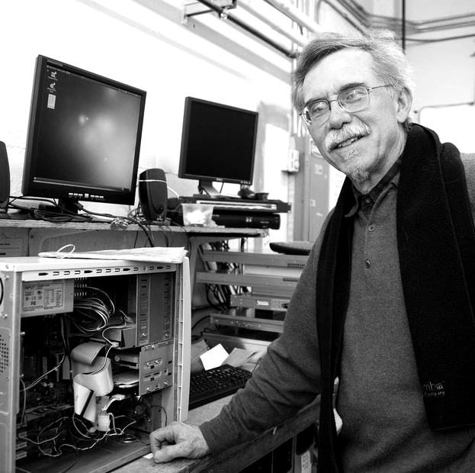

Thank you for helping
Free Geek, a 501(c)3 nonprofit, refurbish technology to provide computers, education and job skills in exchange for community service.

www.freegeek.org

