HOW-TO: CONNECT YOUR PC TO YOUR TV
From the desk of FreeGeek
(NOTE: This how-to is provided free of charge, as-is, with no implied obligation on the part of FreeGeek or its employees. That means that we will not provide any assistance on this problem beyond providing the steps outlined in this paper. So don't bother calling if something goes wrong or if this does not solve your problem. In addition, FreeGeek, its employees and its volunteers hold no responsibility if any damages occur to your property or person as a direct or indirect result of any instructions in this how-to.)

Connecting your laptop or desktop PC computer to your TV may range from something as simple as purchasing a single cable, to having to install a whole new video card in your computer. This guide will help you recognize what you need to connect to your TV.

NOTE: If you have an HDTV, skip the first section of this how-to.

Using S-Video
Figure 1: S-Video Port

- First, look at the back and sides of your desktop and laptop. You want to see if your computer has a port like that shown in figure 1, what is called an S-Video port. Be sure not to confuse this port with the PS/2 port shown in figure 2, as the two are very similar in layout, but perform very different functions.

- If you successfully locate an S-Video port on the rear of your PC, you will now need to check your TV for the same input. If your TV does not have this input, go to the following section.
Figure 2: PS/2 Port

- Purchase a male-to-male S-Video cable long enough for your needs. Connect the two ports, from the back of your computer to the back of the TV, and switch the TV to S-Video input. You should see your display on the TV screen.

Using VGA
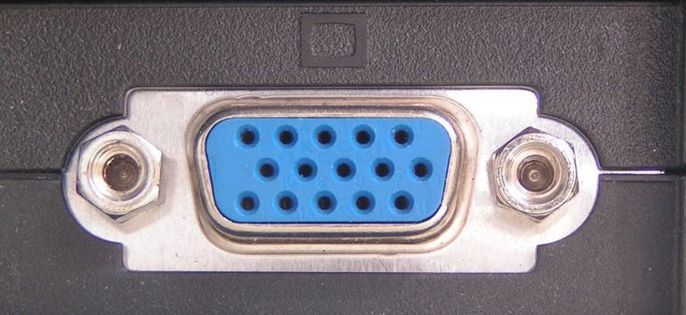Figure 3: VGA Port
- Some standard TVs and most HDTVs come with a VGA port. Nearly every computer will have a VGA output, and usually VGA is how your computer connects to your monitor. The downside of this is that most desktop PCs have only one VGA output, so you will not be able to use both your normal monitor and the TV at the same time.

- If your TV has a VGA port, shown in figure 3, you should purchase a male-to-male VGA cable long enough for your needs. You will connect your computer to the TV using this cable. If you are having trouble finding the VGA port on the back of your computer, make sure it's not currently used by your monitor.

- After connecting the TV and computer, switch your TV to use the VGA input. You should see the computer display on your TV.

Using DVI
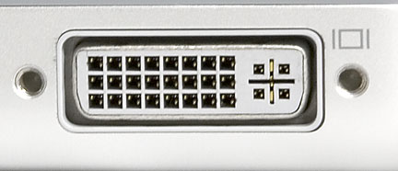Figure 4: DVI Port
- High quality HDTVs and higher-end computers have DVI outputs, which provide higher resolution than either VGA or S-Video. Check the back of your computer for a port like that shown in figure 4. As above, your monitor may be plugged into this port.

- If your computer supports DVI, check the back of your TV for a similar port. If they both have DVI, you can connect the two. Purchase a male-to-male DVI cable long enough for your needs and connect your computer to the back of your TV.

- After connecting your computer, switch your TV to use the DVI input. You should see the computer display on your TV.

NOTE: If none of the steps outlined above apply to your computer or TV, you will likely need to purchase a scan converter box, which takes a VGA signal and converts it into S-Video or component video. These pieces of equipment can be found at electronics stores, but are unlikely to be available at the FreeGeek thrift store.

