Laptop Accessories
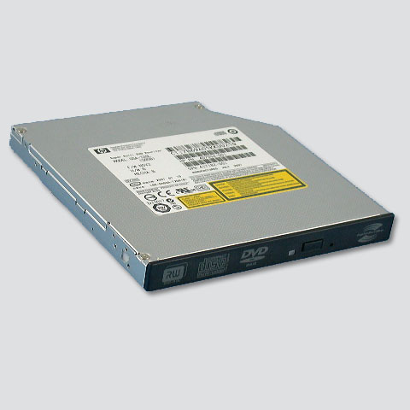    - Laptop Drives (thinner than regular drives) | - Laptop Screens
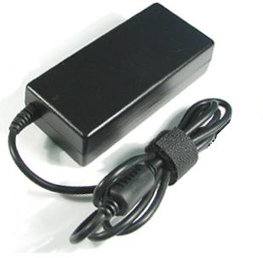  - Laptop Power Adapters |   NO: Laptops  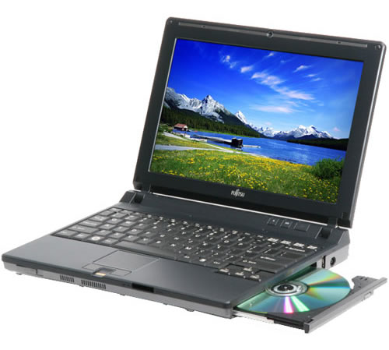  (Give to staff member)
- PCMCIA or PC Cards | 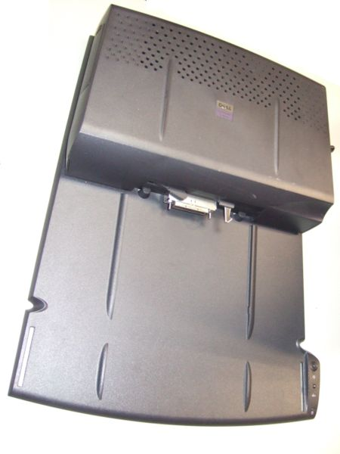  NO: Laptop Docks  (CBM)

