How to Install and Upgrade the Memory (RAM) in Your Computer

Contents:

Section 1: Figuring out what if any RAM is installed
a. Using Ubuntu Linux tools to determine what kind of RAM is installed
b. Opening up your computer
b-i. Desktops
b-ii. Laptops

Section 2: Finding out how much RAM you can install
a. A desktop which may or may not have all the original hardware installed
b. A desktop which has the original hardware or a laptop

Section 3: Some info about the different types of RAM

Section 4: Figuring out how much RAM you need

A note about software:

This guide was written using the Ubuntu Linux LTS release 10.04. Any software referenced will be readily available as part of 10.04. The steps may be similar for Windows or Mac computers, but in order to find out it's best to do an internet search for the specific operating system (OS) you are using. That being said you can still use this guide from a hardware point of view, even if you are using another OS.

Section 1: Figuring out what if any RAM is installed

If you have a functioning computer which will start up, there must be RAM installed. There are a few different ways to figure out what kind and how much RAM is installed in your computer. The first is to use software tools (section 1-a) the second is to actually open up your computer and look inside (section 1-b), the third and probably least reliable is to do an internet search using the make and model of your computer and the words *memory upgrade.*

Section 1-a. Using Ubuntu Linux tools to determine what kind of RAM is installed.

In order to find out what kind of memory is installed on your computer you can use the command line. Open up the terminal application available under Applications --> Acessories --> Terminal (or by holding down ctrl - alt - t on the keyboard). Once there you should see your_user_name@your_computer_name: ~ $

There's a handy little command you can use in order to list all of the hardware on your computer: lshw. In order to get the most information out of this command you should run it as a super user, in other words you'll want to type sudo before the command. Once you type in [sudo lshw] it'll ask you for your password, which when you type it in won't show up for security reasons.

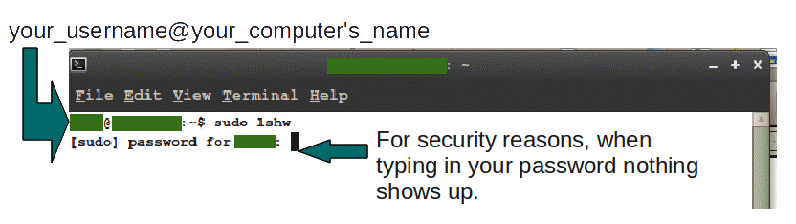

If you want to get a more succinct report back you can type in [sudo lshw -class memory]. Whichever command you chose you'll want to look for the details under *-memory, description: System Memory.
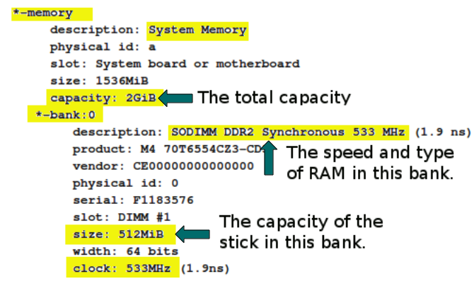
At this point you should be able to see what the total capacity of your RAM is, and the speed and capacity of each stick installed in your computer. For information about speed and capacity of RAM and what that all means check out section 3. Depending on your system, you may not be able to see the specifics of what speed or type of memory is installed.

For information about how to research how much RAM you can install when you are using a desktop computer go to section 2.

For information about how to research how much RAM you can install if you are using a laptop go to section 2-b.

Section 1-b. Opening up your computer to find out just how much RAM is installed.

If you are using a desktop computer it's a fairly simple matter to open up the case and look inside at what kind of memory is installed. If you are using a laptop it may be more difficult, but keep in mind that in order to install more memory you're going to have to open up the computer anyways, so you may as well figure it out now.

If you are using an Apple computer things are complicated by the fact that Apple computers often require proprietary tools in order to perform any type of maintenance. Some are held together by special screws, other systems are held together by a certain type of glue. If you are uncertain as to how to open up your Apple computer it's best to do some internet research before diving in, and especially make sure that you aren't going to void any kind of warranties by opening up your system.

If you're working with a desktop computer please read section 1-b-i.

If you're working with a laptop computer please read section 1-b-ii.

Section 1-b-i. Opening up a desktop computer to find out what kind of RAM is installed.

If you are using a desktop computer it should be simple to open up the case and look inside. Each case is different, but most are fairly straight forward to get open. If you find you are having trouble try looking online for guides on opening your case.

When handling the RAM, or touching your motherboard it's a good idea to keep yourself grounded by touching the inside of the case with your free hand. That way you will not risk discharging and static electricity into the board, which can ruin your computer. To remove the stick push down on the white tabs on either side of the slot. The RAM will pop up and out of the slot.

Most motherboards will either have two or four slots for memory. Each slot type should be the same, although there are a few motherboards which will have two different types of slots on one board. If you're not sure, try removing the stick of RAM already installed in your computer and inserting it into any of the other slots.
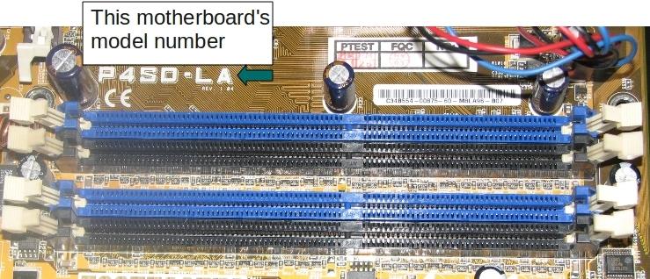RAM slots on a motherboard

The slots on the RAM should line up with the slots on the motherboard, and the RAM should be easily seated in the slot. If not, it probably means you've got two different types on your board. Remember that this isn't a very common occurrence, so take your time to make sure you're doing everything correctly.

Once you've got the RAM free take a look at the manufacturer's sticker on the side of the stick. Some stickers are more informative than others, but most should tell you what capacity and what speed your memory is. If you can't immediately tell, try looking at the model number. For example if the sticker says something like KVR333/256 you can tell that it's a 256 MB stick of 266 Mhz DDR. Be careful though, because sometimes these can point to the capacity of a pair of sticks of RAM. When this is the case you may have two sticks of RAM which total 1 G but are individually only 512 MB. For a guide on types of RAM and speeds go to section 3.
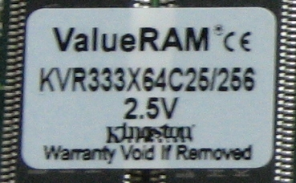A typical RAM label

When you know what kind of memory is installed you'll want to reinstall it into the motherboard. Make sure you push it down all the way into the slots, so the levers pop back on their own. You shouldn't have to force it, but sometimes you have to push down rather hard. If you're having troubles make sure the RAM is lined up with the slot correctly. If you don't have it installed correctly your computer will make a beeping noise when you turn it on, or won't be running as well. If you want instruction on how to double check that your system is recognizing all the memory read section 1-a.

Now that you know what type and how much memory is installed on your computer you can get started with finding more memory. However you'll still need to figure out how much memory can be installed into your computer. Each motherboard has a different capacity at which it will cap out, where you can't install any more memory. It may be the case that you are already at the maximum memory installed in your computer. So, how do you find out how much can be installed? Do some internet research.

For information about how to research how much RAM you can install when you are using a desktop computer go to section 2.

Section 1-b-ii. Opening up a laptop to find out how much RAM is installed.

Most laptops will have space for two sticks of RAM. However it can be difficult to find where and how to open up the system to replace the memory. Some laptops have both the RAM sticks installed in one location, accessible through a panel on the bottom of the machine. Others have one there, and another under the keyboard. The best way to find out, once again, is to do some internet research. Try finding manuals from the manufacturer's website.

Once you've figured out how to access the RAM, you'll need to take a look at any labels. When handling the memory it's important to remember to be careful not to discharge any static electricity into the motherboard of the computer, or to the contacts of the RAM. Ground yourself by touching a piece of metal, and try to avoid touching the contacts of the memory chip.
A typical RAM label
Once you've got the RAM free take a look at the manufacturer's sticker on the side of the stick. Some stickers are more informative than others, but most should tell you what capacity and what speed your memory is. If you can't immediately tell, try looking at the model number. For example if the sticker says something like KVR333/256 you can tell that it's a 256 MB stick of 266 Mhz DDR. For a guide on types of RAM and speeds go to section 3.

When you know what kind of memory is installed you'll want to reinstall it into the motherboard. Make sure you push it down all the way into the slots, so the levers pop back on their own. You shouldn't have to force it, but sometimes you have to push down rather hard. If you're having troubles make sure the RAM is lined up with the slot correctly. If you don't have it installed correctly your computer will make a beeping noise when you turn it on, or won't be running as well. If you want instruction on how to double check that your system is recognizing all the memory read section 1-a.

Now that you know what type and how much memory is installed on your computer you can get started with finding more memory. However you'll still need to figure out how much memory can be installed into your computer. Each motherboard has a different capacity at which it will cap out, where you can't install any more memory. It may be the case that you are already at the maximum memory installed in your computer. So, how do you find out how much can be installed? Do some internet research.

For information about how to research how much RAM you can install when you are using a laptop computer go to section 2-b.

Section 2: Finding out how much RAM you can install.

The first question you'll need to ask yourself is whether you know with absolute surety that the motherboard installed in the computer is the original one which came with the machine. Did you buy the computer new? If you bought it used and there's even a small chance that the motherboard has been swapped out at some point skip to section 2-a.

If you bought the computer new, and you know that no changes have been made go to section 2-b.

Section 2-a. Finding out how much RAM you can install on a desktop which may not have the original motherboard.

If you're not sure about the history of the computer you are using you'll want to open the machine up and look inside. This should be fairly straight forward, but if you can't figure out how to get it open try doing an internet search for the specific make and model of computer you have.

Once inside you'll need to find the model number of the motherboard. This can be fairly tricky with certain motherboards, but usually your best bet is to go with the most prominent string of numbers you can find printed on there (especially if you can find a brand name printed next to those numbers). Once you've got the best option, or a couple of options you'll want to write those down and close your computer back up. You can then go online and search for the string you found to see if that is indeed the model of your motherboard, or determine what is. As soon as you know for sure you should search that model plus the words *memory upgrade* There's lots of good sites out there which will guide you with just how much memory you can install into your motherboard. Try to find one which will tell you the capacity per slot, as well as the total capacity.

You're ready now to purchase your shiny new (or used) sticks of RAM.

Section 2-b. Finding out how much RAM you can install on a desktop which has the original hardware, as well as on a laptop.

If you need to find out how much RAM you can install on a desktop computer with the original hardware, or if you have a laptop it's a pretty simple process. You'll just need to find the model number of your computer, which should be printed somewhere on the case, and type that into any search engine along with the words *memory upgrade* You can look at the manufacturer's website for information, however be careful to look for info on how much you can install, not just what originally came with the machine. There are other good sources of information out there on the web, many memory manufacturers will have good listings and search engines on their websites.

You're ready now to purchase your shiny new (or used) sticks of RAM.

Section 3. Some information about the different types of RAM.

These are the most common types of RAM still in circulation today:

SDRAM |  | DDR |  | DDR2 |  | DDR3
Mhz | PC-number | Mhz | PC-number | Mhz | PC-number | Mhz | PC-number
100 | PC-100 | 200 | PC-1600 | 400 | PC2-3200 | 1333 | PC3-10600
133 | PC-133 | 266 | PC-2100 | 533 | PC2-4200 | 1600 | PC3-12800
 |  | 333 | PC-2700 | 667 | PC2-5300 | 1800 | PC3-14400
 |  | 400 | PC-3200 | 800 | PC2-6400 | 2000 | PC3-16000
 |  |  |  | 1066 | PC2-8500

Laptop RAM is known as SODIMM, and desktop RAM DIMM. There is also a significant difference in size between the two. Laptop RAM chips are half the size of normal desktop memory.

The term SDRAM applies to most types of RAM in circulation today. PC 100 and PC 133 are easily differentiated from DDR RAM because they have two slots in the bottom of the stick, whereas DDR types only have one. Each type of DDR RAM has the slot in a slightly different spot from the last, however it can be very difficult to discern the difference by sight without another stick for comparison.
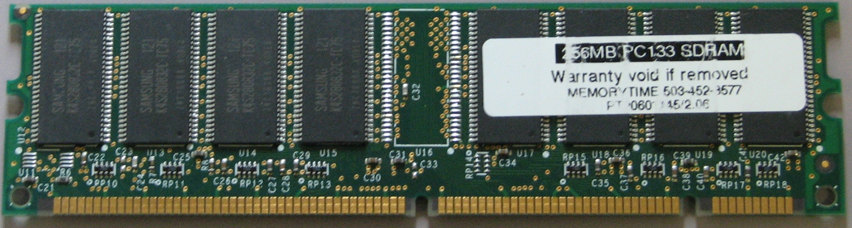PC 133 SDRAM - two slots
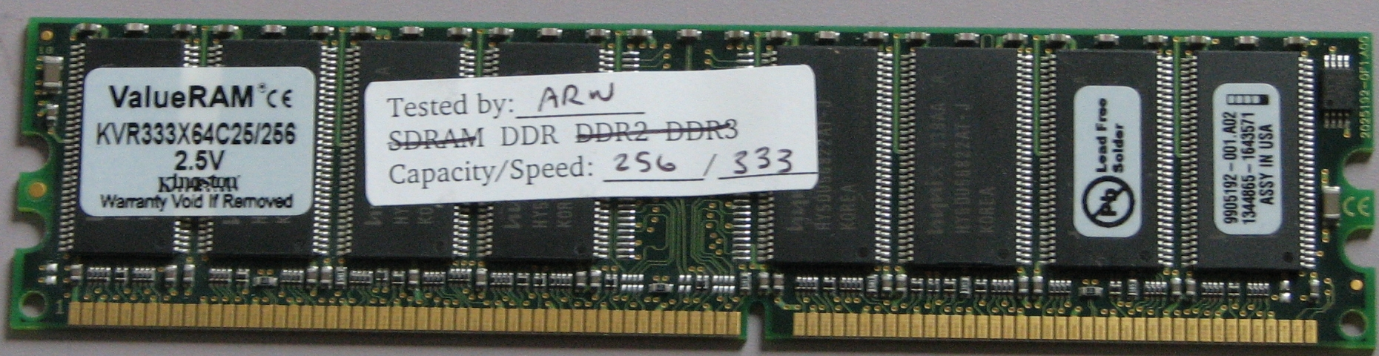DDR SDRAM - only one slot

For each type there are different speeds or frequencies at which the RAM runs. It is important to note that speed and capacity are two different things both of which affect the operation of the RAM and therefore your computer. Older RAM generally comes in capacities of 128, 256, and 512MB sticks. Newer models will be available in 1 GB capacities and up.

Some of the older types of RAM are more proprietary, especially RDRAM. This means that a motherboard which accepts these types of RAM will only take one or two specific speeds. Most motherboards will accept more than one speed of RAM. If a board will take DDR2 533, it's likely that it will also accept DDR2 400, or DDR2 667 or both. One way to know for sure is to look up your motherboard online, to find information from the manufacturer, or from another website. Alternatively you can try multiple speeds of RAM to see whether they function in the board.

RAM chips are backwards compatible, meaning if you already have one stick of DDR2 533 installed, you could theoretically install a stick of DDR2 400. The 533 stick would drop down to and run at 400 Mhz. It's not necessarily advisable to do this, as you are losing some of the speed and efficiency of the RAM, however it's not going to make a hugely noticeable difference.

Section 4. Figuring out how much memory you need.

Memory works as a temporary storage space for your computer. If your computer were a desk, the memory would be the surface on which you put files onto while working on them. Nothing is permanently stored on this surface, these files are pulled from and returned to the drawers (the hard drive) each time you manipulate them. When you are pulling multiple files at the same time, you need a larger surface, or more memory. The most memory intensive tasks are those which involve video, audio, or user input. Tasks which combine all three, like gaming, generally require a large amount of free memory space. Other memory intensive tasks include video editing, and design or professional work. Most programs or games will have recommendations as to what the minimum memory requirements are for running them. It's also useful to note that there are video cards manufactured which have their own repository of memory, for video intensive programs and functions.

In general the more RAM you have the better your computer will run. However, fast RAM in moderate amounts is better than very slow RAM in large quantities. If you find your computer runs fine when you don't have many programs running, you would probably benefit from getting more RAM in your system. If it's slow all the time, RAM can help, but it might be another issue.

You may also want to look at the requirements of the Operating System you are running. Most distributions of Linux are relatively low-requirement, and recommend 512 MB of RAM installed. However there are some distributions which are made to run on even less, so if you are trying to just go with the basics it certainly is possible. It's also good to note that while 512 MB may be the 'recommended' install, if you are doing more intensive tasks with your system it may require a memory upgrade.

