Build Packet

Welcome to the Build Program at Free Geek!
Anyone may participate in this program as long as they are able to make it to our facility to volunteer. Volunteers under the age of 16 must be accompanied by a parent or guardian.

Making the Commitment
The build program is an estimated 60 to 80 hour time commitment over the course of about 8 weeks. Shifts are available during set hours only, depending on which area you are working in (see Steps of the Build Program). After going through the initial stages of the build program and building five computers, you may take the sixth one home! Computers can be obtained only once per year.
Please be eager to learn and work with the Ubuntu Linux operating system. You can find out more about this operating system at http://ubuntu.com/ and at Free Geek.
The structure of the build program is illustrated on the following page.

Free Geek Culture
In the build program, we work and learn in a workshop style. We encourage you to ask questions of your instructors and fellow volunteers. This is an integral part of the build process. You may take notes if you like.

Documentation
There is a lot of information on our programs and procedures at http://wiki.freegeek.org, which is our wiki. Search for something like “build” to see what comes up. Review the following documents before starting a new task to get a head start, and whenever you need a refresher.

- Prebuild Documents
  - Card Sorting: http://wiki.freegeek.org/index.php/Card_Sorting
  - Motherboard Sorting: http://wiki.freegeek.org/index.php/Motherboard_Sorting
  - Hardware Identification (Case Management) and System Evaluation: http://wiki.freegeek.org/index.php/System_Evaluation
- Build Workshop Documents
  - A nice overview: http://wiki.freegeek.org/index.php/Build
  - Building your first computer: http://wiki.freegeek.org/index.php/Build_sheet
  - Community-gathered tips on building: http://wiki.freegeek.org/index.php/Build_tips

Internet
Wondering what all those beeps mean when you startup that problem machine? Can't figure out the speed of the processor? Google (or the search engine of your choice) is a resource for all computer builders on tough issues. It is helpful to include the word “Ubuntu” in your search.
Some other good resources include http://www.ubuntu.com/ and http://ubuntuforums.org/.
There are terminals in the build workshop as well as in system evaluation for just this purpose. Feel free to use them!
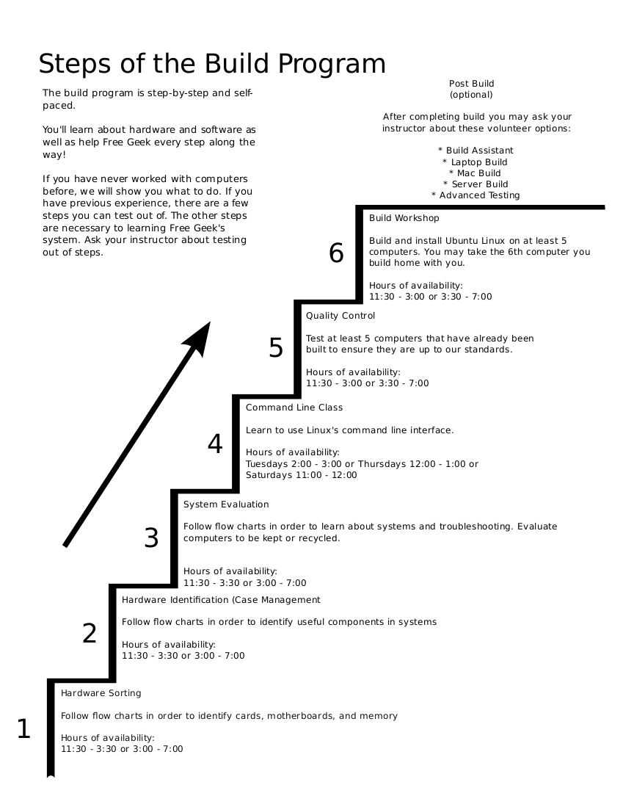

Tools to Make Life Easier

Health and Safety, Rah Rah Rah!
Please stay safe. There are lots of pointy things and tall piles of computer stuff at Free Geek. We ask the following of you while you're here:
- Be careful, wear shoes, dress appropriately for your task, and alert a staff member if you see an unsafe situation that needs attention.
- If anything starts hurting while you're volunteering, let us know and we'll have you do a different task.
- If you are living with a blood-borne disease (like Hepatitis C or HIV), please let a staff member know. Also, if you are cut at Free Geek and spill blood, let the closest staff member know so that he or she may act and give directions to others accordingly. Although we are invested in guarding your privacy, we request that you allow us to inform other staff members of the situation.
- If you need any special consideration at all, let a staff member know so that we can work with you and help you get the most from your volunteer experience.
- Free Geek is a safe, respectful place. We don't allow harassment, violence, theft, arson, or other destructive behaviors here. Sexist, racist, homophobic, or other threatening language, clothing, or behaviors will not be tolerated.

Contact Us
For reference, here's Free Geek's contact info. Thanks for volunteering at Free Geek!
Free Geek Community Technology Center
1731 SE 10th Avenue
Portland, OR 97214
Open Tuesday through Saturday, 11:00 AM – 7:00 PM
Tel (503)232-9350
http://freegeek.org

