USB Cables
(Universal Serial Bus)

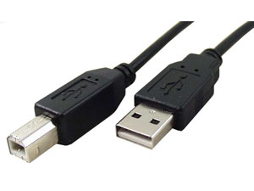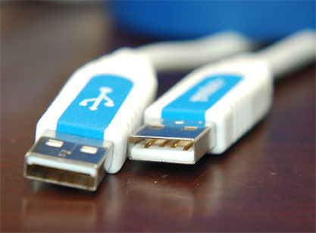

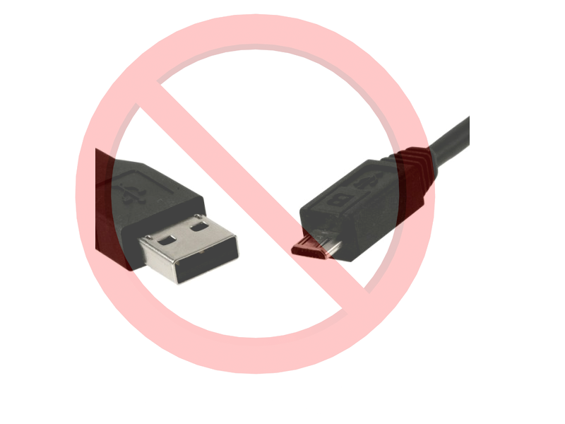
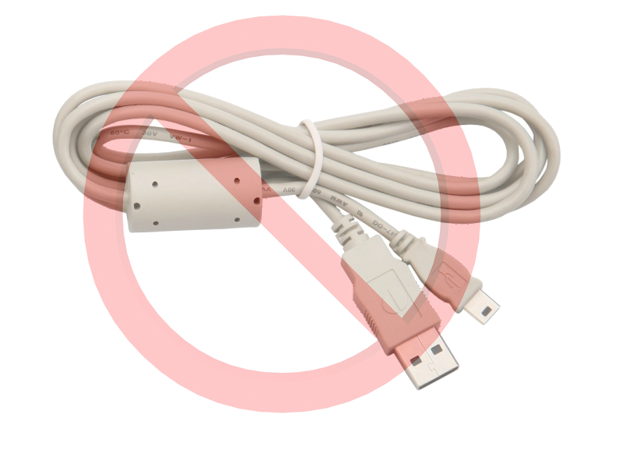

Put USB mini in Send micro to the
Cell Phone Accessories Store Box

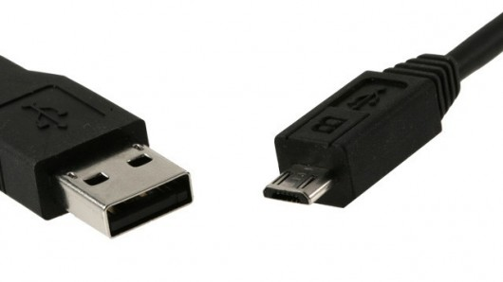
USB Cables
(Universal Serial Bus)

Put USB mini in Send micro to the
Cell Phone Accessories Store Box

